BOOK ME

Need To develop clean website design professional Website for Travel Market Place

Some Competitors websites are here as a reference

1-https://www.transfeero.com/en/

2-https://www.hoppa.com/en

3-https://www.holidayautos.com/

4-https://www.mozio.com/en-us/

5-https://www.jayride.com/

6-https://city-airport-taxis.com/

Our Booking Form

<https://booking.hypersoftwares.com/bookme>

CURRENT

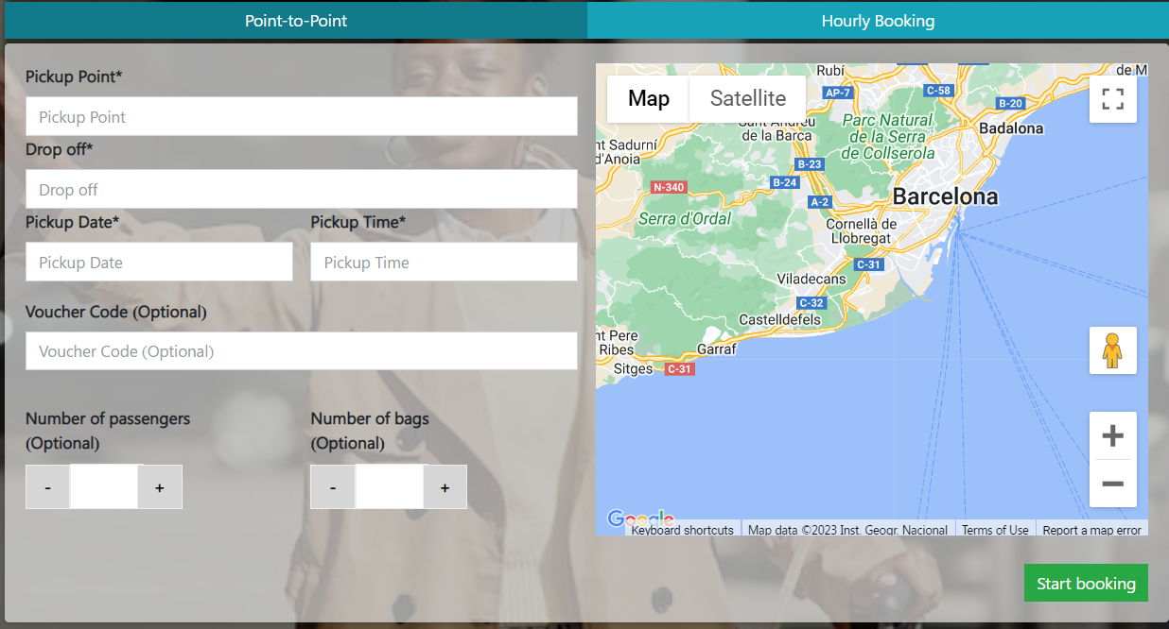

1. Make Date & Time At same place for reference you can visit website: <https://www.hoppa.com/en>

When To select Date next ask for Time Also for return Trip just click on Add Return so there come for select return date and time so it’s nice.

Its example you can make its better design and latest style if you think that is best because this ref website is old so we are doing now so our style and design should be more updated and attractive

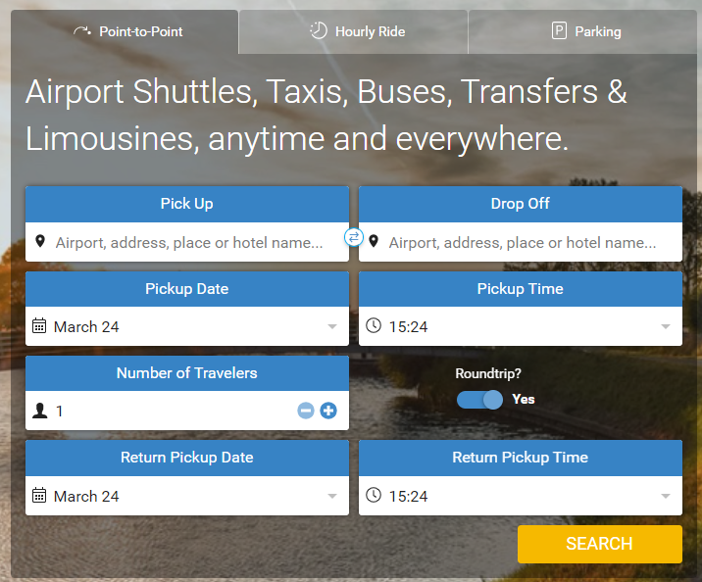

This is from another website where can hide and show round trip

So, In our bookme form we need to add option for return trip and remove Voucher code and number of bags

Because voucher he can use at the end time of payment

Next Steps

Display search requested data from server database   
  
All Available Option from all suppliers for that requested ride

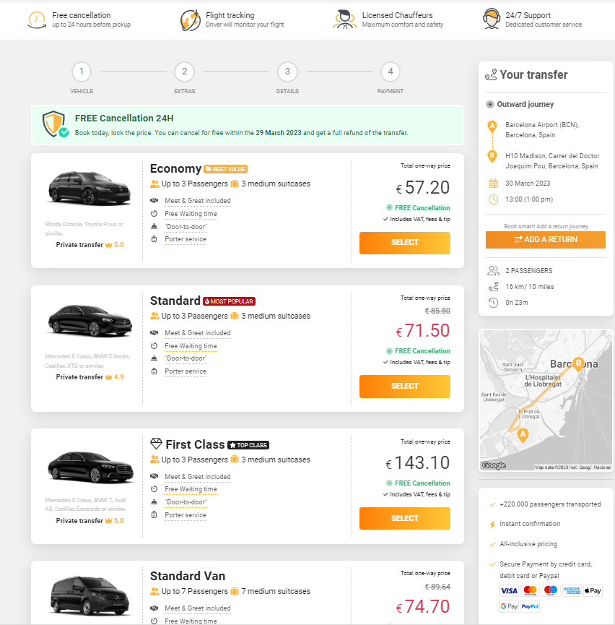

Once Client will Select His required Vehicle Next Step for select EXTRA OPTION

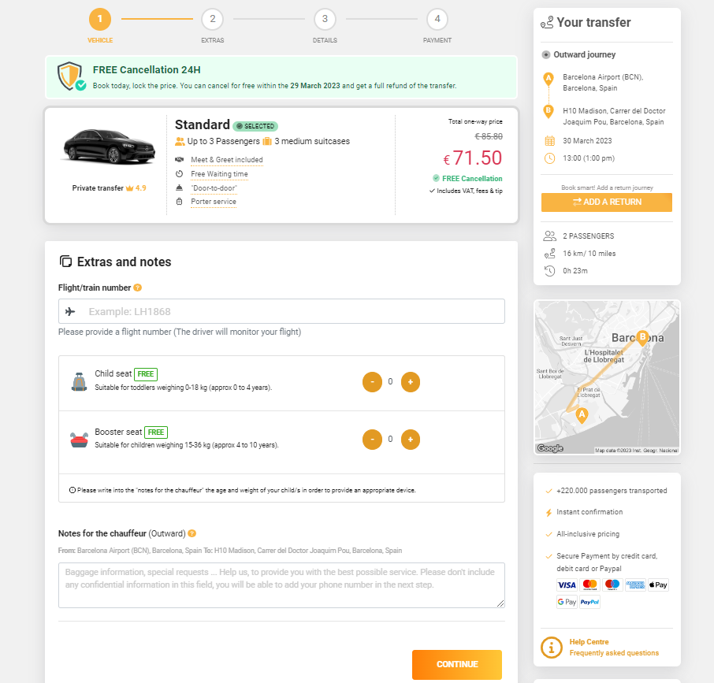

Here we can add Option for Add extra like Child Seat/Boster/pet/simcard/extra thing we can be chargeable and free also flight number and Note for chuffer

Next step if customer data

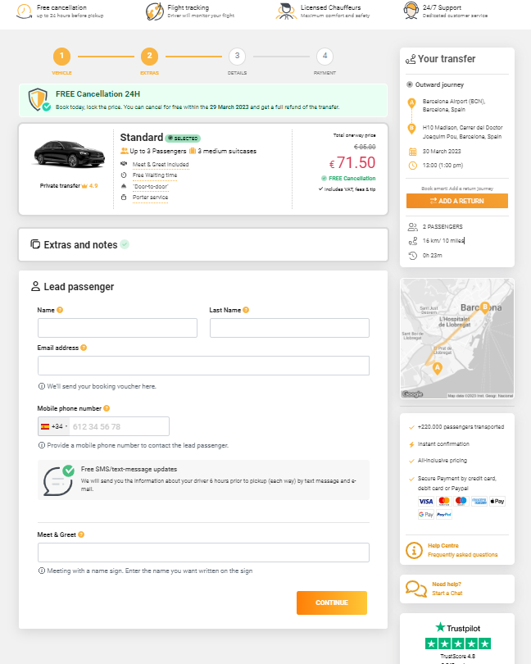

Here we will ask from customer Lead Guest Name and email phone number

And meet and greet

NEXT IS PAYMENT AND CONFIRMATION

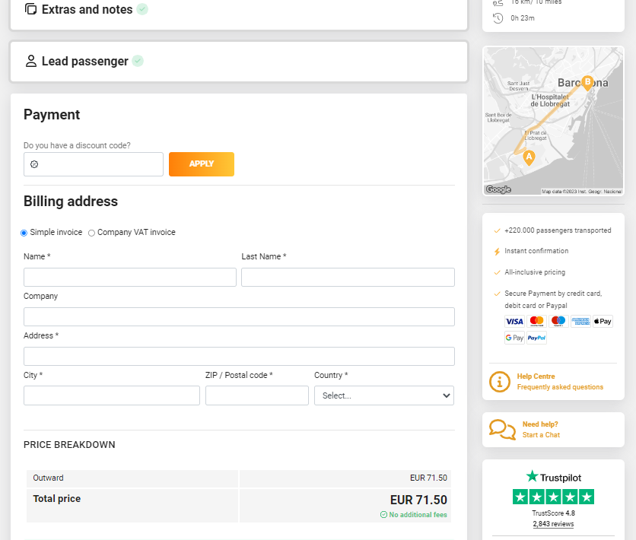

After Payment Complete BOOKING WILL GO SUPPLIER BOOKINGS then he have to Accept that booking after supplier accepted booking Customer will received confirmation voucher of his trip by email

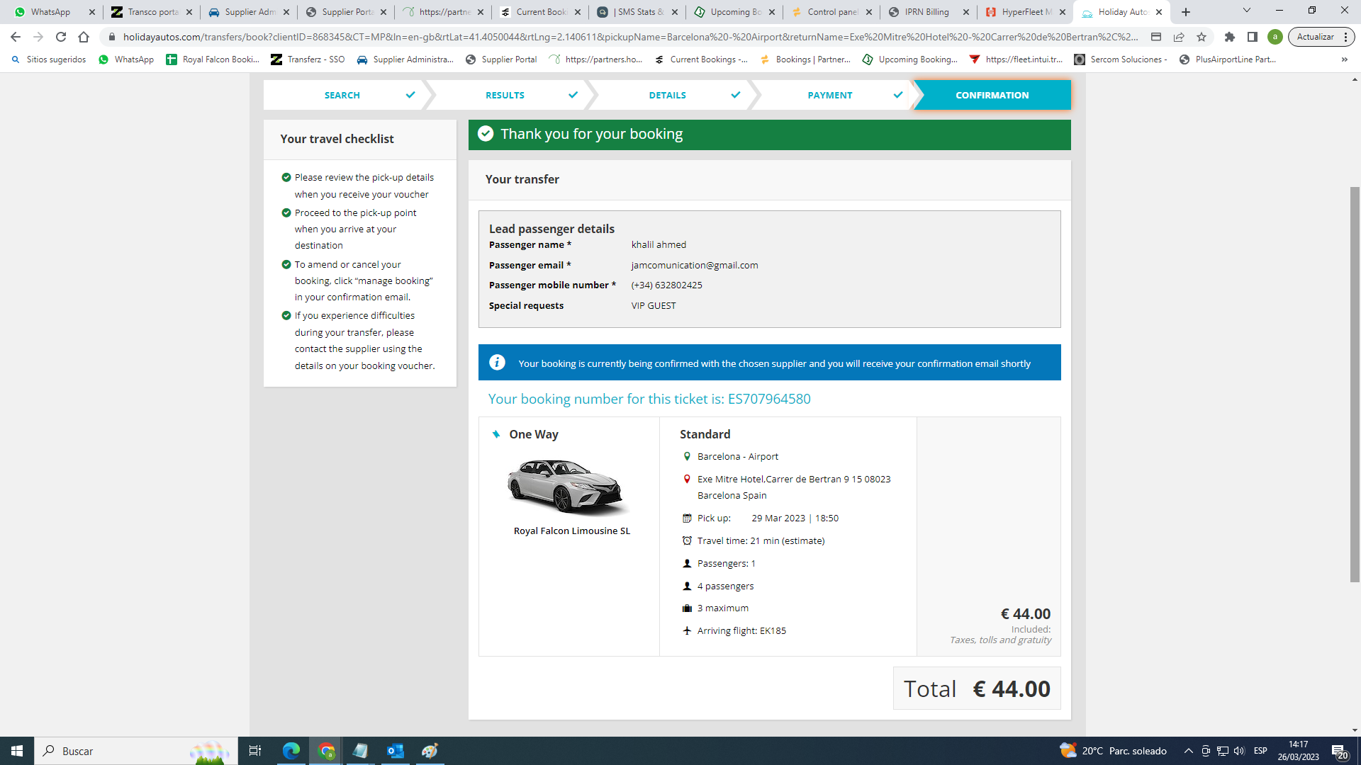

Client Payment made booking sent to supplier

Supplier decline booking saying no availability

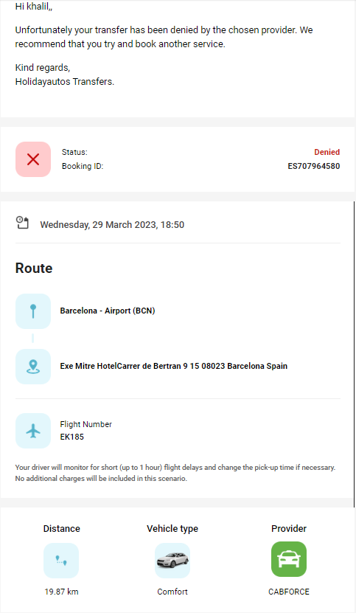

Client Not get charged until confirmation from supplier side

Until Supplier Not accept booking customer will not get his confirmation for this trip